**The win ratio and win odds analysis of pulmonary arterial hypertension clinical trials**

**Supplementary material**

Table of Contents

Table S1: Baseline characteristics of study participants 8

Table S2: Win statistics without stratification by trial with stratification by baseline WHO functional class [Sensitivity analysis I] 9

Table S3: Win statistics without stratification by trial with clinical worsening ranked before clinical improvement in the event hierarchy [Sensitivity analysis II] 10

Figure S1: Win statistics over time without stratification by trial 11

Figure S2: Trial-stratified win statistics 12

Figure S3: Trial-stratified win statistics with stratification by baseline WHO functional class [Sensitivity analysis I] 14

Figure S4: Trial-stratified win statistics with clinical worsening ranked before clinical improvement in the event hierarchy [Sensitivity analysis II] 16

## **Table S1: Baseline characteristics of study participants**

|  |  |  |  |  |
| --- | --- | --- | --- | --- |
| Characteristic | N | Overall  N = 6,619 | Active therapy  N = 3,969 | Control  N = 2,650 |
| Age (years) | 6,616 | 49.2 ± 15.4 | 49.2 ± 15.4 | 49.3 ± 15.4 |
| Sex (female) | 6,619 | 5,187 (78.4) | 3,109 (78.3) | 2,078 (78.4) |
| Body mass index (kg/m2) | 6,619 | 27.1 ± 5.7 | 27.0 ± 5.7 | 27.3 ± 5.7 |
| PAH etiology | 6,609 |  |  |  |
| Idiopathic |  | 3,980 (60.2) | 2,376 (59.9) | 1,604 (60.6) |
| Associated with connective tissue disease |  | 1,843 (27.9) | 1,117 (28.2) | 726 (27.4) |
| Associated with congenital heart disease |  | 518 (7.8) | 312 (7.9) | 206 (7.8) |
| Drug and toxin-induced |  | 120 (1.8) | 69 (1.7) | 51 (1.9) |
| Heritable/familial |  | 70 (1.1) | 43 (1.1) | 27 (1.0) |
| Associated with HIV infection |  | 65 (1.0) | 36 (0.9) | 29 (1.1) |
| Portopulmonary hypertension |  | 13 (0.2) | 11 (0.3) | 2 (0.1) |
| WHO functional class | 6,615 |  |  |  |
| I |  | 48 (0.7) | 31 (0.8) | 17 (0.6) |
| II |  | 2,225 (33.6) | 1,377 (34.7) | 848 (32.0) |
| III |  | 4,133 (62.5) | 2,443 (61.6) | 1,690 (63.8) |
| IV |  | 209 (3.2) | 117 (2.9) | 92 (3.5) |
| Six-minute walk distance (m) | 6,616 | 347.0 ± 83.8 | 348.6 ± 81.9 | 344.6 ± 86.5 |
| Background PAH therapy | 6,619 |  |  |  |
| None |  | 4,135 (62.5) | 2,536 (63.9) | 1,599 (60.3) |
| Monotherapy |  | 1,954 (29.5) | 1,171 (29.5) | 783 (29.5) |
| Dual therapy |  | 530 (8.0) | 262 (6.6) | 268 (10.1) |

Values are n (%) or mean ± SD

## **Table S2: Win statistics without stratification by trial** **with stratification by baseline WHO functional class [Sensitivity analysis I]**

|  |  |
| --- | --- |
| **Win Ratio (95% CI)** | 1.81 (1.47, 2.22) |
| **Win Odds** | 1.36 (1.22, 1.52) |
| **Net benefit** | 0.15 (0.10, 0.21) |

## **Table S3: Win statistics without stratification by trial with clinical worsening ranked before clinical improvement in the event hierarchy [Sensitivity analysis II]**

|  |  |  |  |  |  |  |
| --- | --- | --- | --- | --- | --- | --- |
|  | **Composite endpoint components for 3,969 (active) x 2,650 (control)=10,517,850 patient pairs** | | | | | |
|  | **Death** | **Lung transplant** | **PAH Hospitalization** | **Worsening PAH** | **Clinical improvement** | **Total** |
| **Number of patients with the event** | 259 | 5 | 617 | 1,258 | 788 | 2,927 |
| **Number of Wins for active treatment arm** | 268,451 | 7,679 | 547,889 | 508,683 | 1,338,706 | **2,671,408** |
| **Number of Losses for active treatment arm** | 192,668 | 6,464 | 320,377 | 266,549 | 757,929 | **1,543,987** |
| **Number of Ties** | 10,056,731 | 10,042,588 | 9,174,322 | 8,399,090 | 6,302,455 | **6,302,455** |
| **Total number of patient pairs** | 10,517,850 | 10,056,731 | 10,042,588 | 9,174,322 | 8,399,090 | **10,517,850** |
| **Win Ratio** | 1.39 | 1.19 | 1.71 | 1.91 | 1.77 | **1.72 (1.47, 2.02)\*** |
| **Win Odds** | 1.01 | 1.00 | 1.05 | 1.05 | 1.15 | **1.40 (1.27, 1.54)\*** |
| **Net benefit** | 0.01 | 0.00 | 0.02 | 0.02 | 0.06 | **0.17 (0.12, 0.22)\*** |

*With inverse-probability-of-censoring weighting, p < 0.001

## **Figure S1: Win statistics over time without stratification by trial**

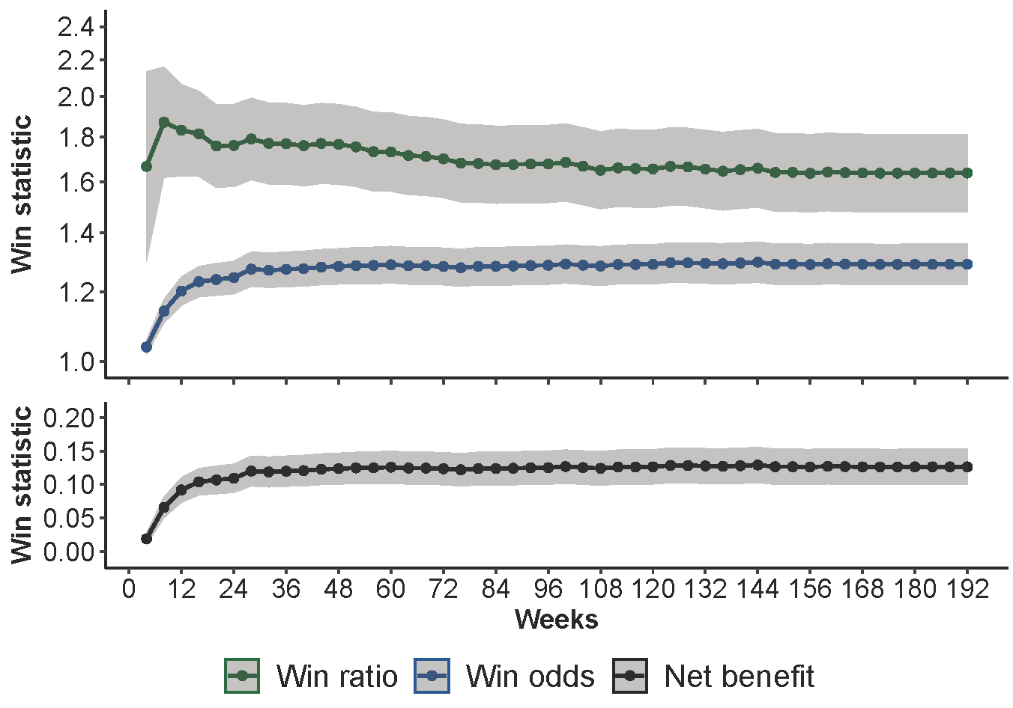

## **Figure S2: Trial-stratified win statistics**







## **Figure S3: Trial-stratified win statistics with stratification by baseline WHO functional class [Sensitivity analysis I]**







## **Figure S4: Trial-stratified win statistics with clinical worsening ranked before clinical improvement in the event hierarchy [Sensitivity analysis II]**





